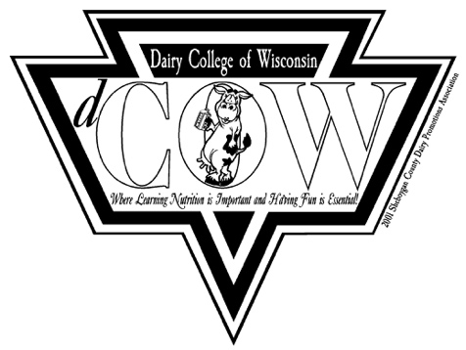
Sheboygan County
Dairy Promotions Association
5 University Drive, Sheboygan, WI • (920) 459-5902
www.sheboygancountydairypromotion.com

The Sheboygan County Dairy Promotions Association is offering one $1000 scholarship and one $500 scholarship to Sheboygan County high school seniors enrolling in a post high school education program or those currently enrolled in their first year of post- or secondary education.

Eligibility

- Applicant must be a high school senior or post high school student in their first year of higher education to be eligible to apply.
- The applicant must be entering an Agriculture or Food Science related field of study.
- Educational institution/program that is any professional technical, vocational, 2-year or 4-year college to training equivalent or at least one year in school length.
- Applicant must be available for an interview if deemed necessary by the Sheboygan County Dairy Promotion Association.
- Applicant must provide a photo and a self introduction with future career goals to the committee by April 30th, 2022. Photo and self introduction will be posted on our Facebook page.
- Applicants must volunteer for the Breakfast on the Farm on June 18th, 2022. Strack-View Dairy - Random Lake. To volunteer, go to website www.sheboygancountydairypromotion.com prior to the breakfast and fill in “sign up Genius”
- Scholarship recipient/s will be awarded at the 2022 Breakfast on the Farm.

Return to Secretary- Katie Mullikin by April 30th
katiewade21@gmail.com

Scholarship money will be dispensed in January for the spring semester after proof of enrollment is provided by the student.
Please send to Treasure- Kim Gartman
kimbermay@hotmail.com

Scholarship money will go directly to the winner’s school of choice.

Any changes to the questions in the document other than your answer will automatically disqualify you. We are leaving this in an easy format for your convince.
Dairy Products are Nutritional and Fun – Key Elements in a Happy Body and Mind!

Sheboygan County Dairy Promotions Association Scholarship
Application Rating Sheet

Applicant’s Name:

4-H Club/FFA Chapter/School:

Possible Score

- Essay: Importance of the dairy industry and promoting its products
Comments:

30

- Participation in dairy promotion activities
Comments:

25

- Leadership role in dairy promotion activities
Comments:

25

- Extracurricular and service activities
Comments:

10

- Awards and accomplishments
Comments:

5

- Quality of Application (grammar, spelling, neatness, etc.)
Comments:

5
100

Reviewed by: Total

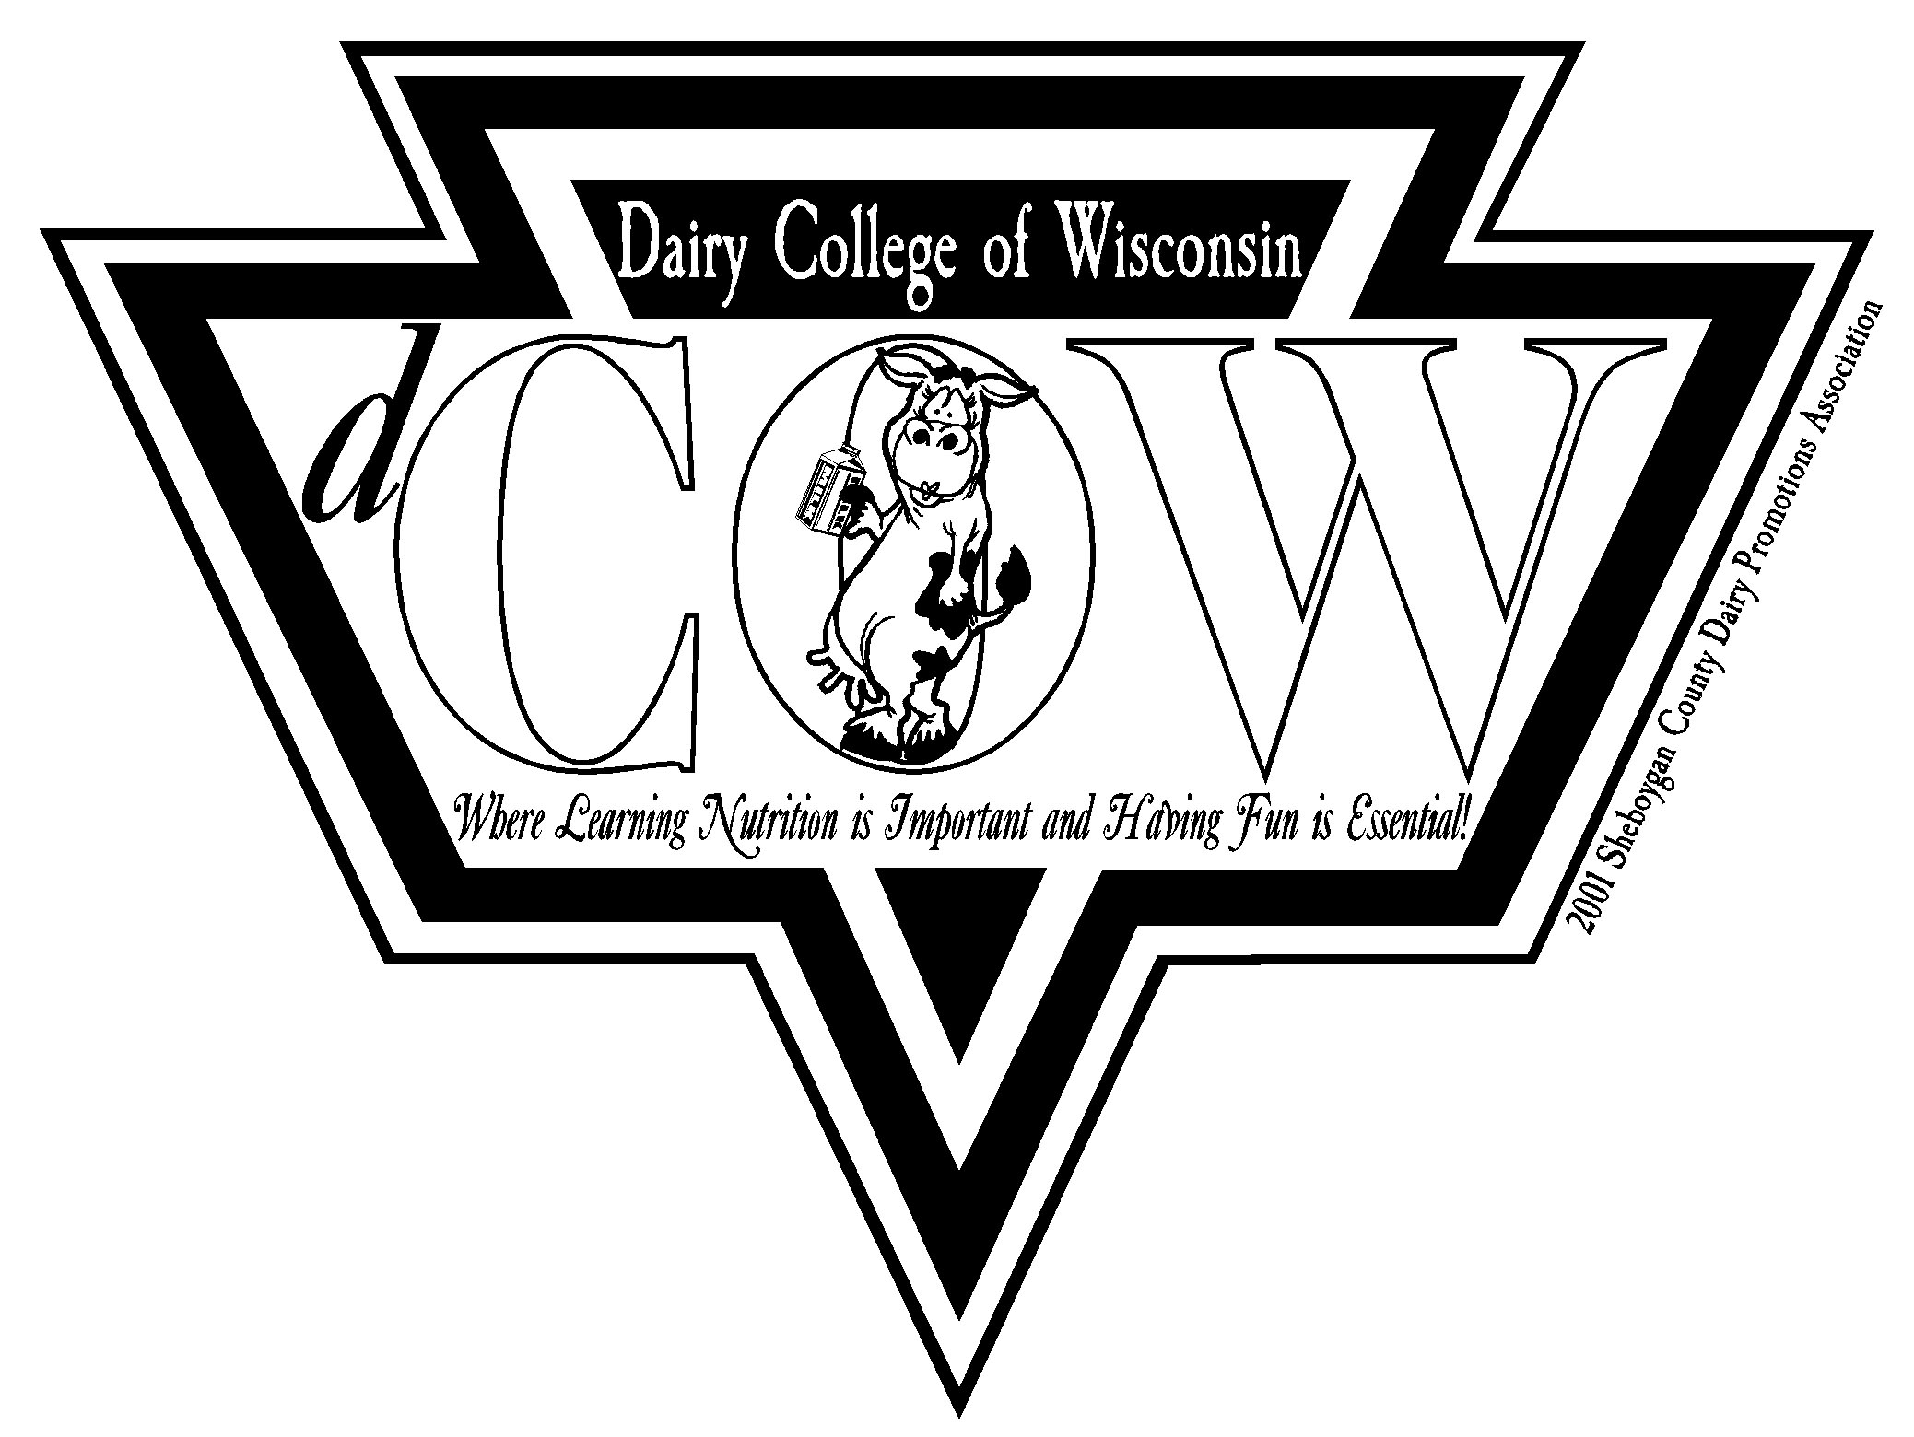
Sheboygan County
Dairy Promotions Association

5 University Drive, Sheboygan, WI • (920) 459-5902

Sheboygan County
Dairy Promotions Association
Scholarship Application

Please print or type:

Name: Age: ______ Birth date:

Address: City: __________________ Zip:

Parent or Guardian Phone:

High School attending:

Name and address of school where scholarship will be used:

Field of study:

Information: (additional pages may be used)

Please list the dairy promotion activities that you have participated in on the local and county level, individually or with your club. (Examples: family farms, jobs, dairy posters, window displays, farm tours, Breakfast on the Farm, Food for America, etc.) (25 pts)

List any leadership opportunities you have had in promoting dairy products and the dairy industry. (25 pts)

List extracurricular or service activities you have participated in including number of years and offices held. (i.e. 4-H, Scouts, FFA, church or sports) (10 pts)

Please list awards and accomplishments. (5 pts)

On a separate sheet of paper, please answer the following in 100 words or less – describe your feelings about the dairy industry and promoting its products. (30 pts)

